Phase 4 – Advanced SQL Engineering
Project: Enterprise ERP Analytics Implementation
Prepared By: Vikash Kumar Singh
Date: 06-Aug-2026.

Mandatory SQL Tasks :-

25 Complex JOIN Queries :-

- SELECT a.order_id, a.company_name, b.product_name
FROM logistics_erp a
JOIN logistics_erp b ON a.order_id = b.order_id;

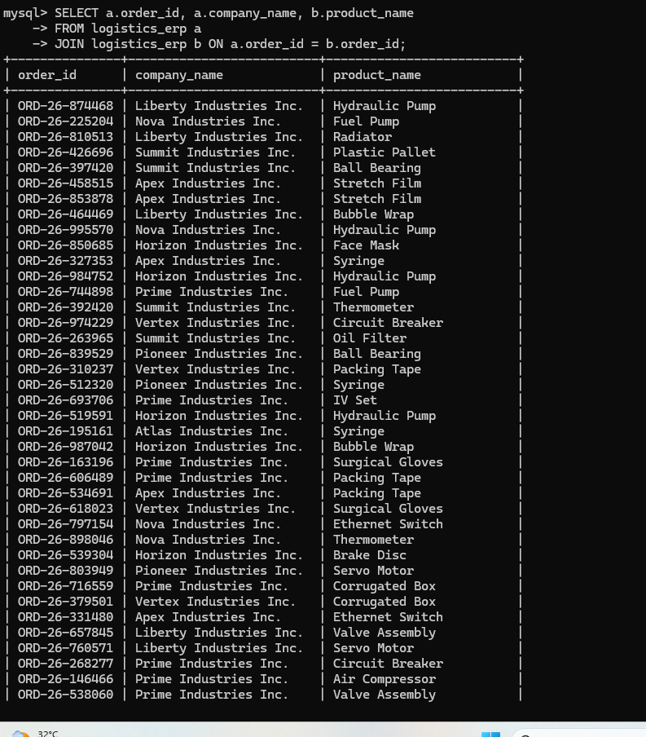

SELECT a.customer_id, COUNT(DISTINCT b.product_id) total_products FROM logistics_erp a

JOIN logistics_erp b ON a.customer_id = b.customer_id

GROUP BY a.customer_id;

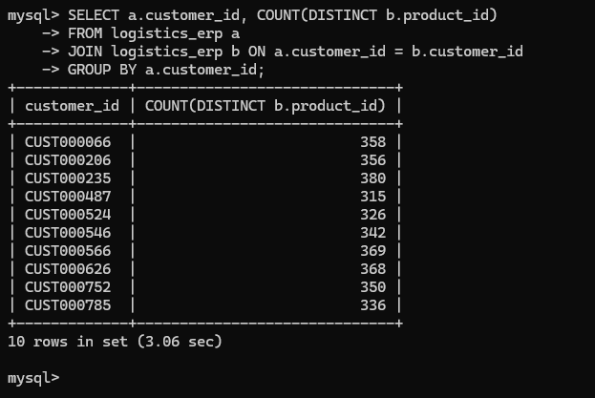

3 SELECT a.product_category, SUM(b.order_value) total_sales

FROM logistics_erp a

JOIN logistics_erp b ON a.product_id = b.product_id

GROUP BY a.product_category;

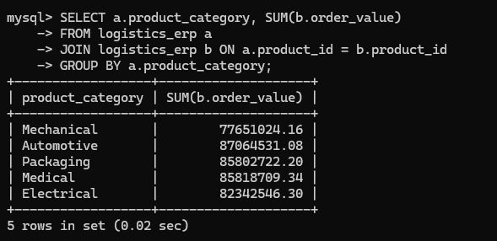

4. SELECT a.courier, COUNT(b.order_id)

FROM logistics_erp a

JOIN logistics_erp b ON a.courier = b.courier

GROUP BY a.courier;

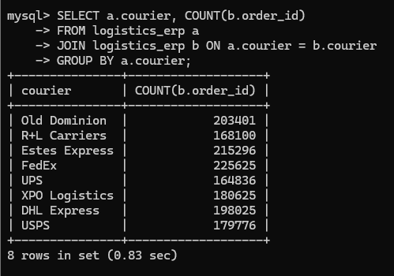

5. SELECT a.warehouse, SUM(b.closing_qty)

FROM logistics_erp a

JOIN logistics_erp b ON a.warehouse = b.warehouse

GROUP BY a.warehouse;

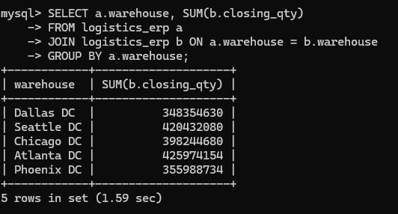

6. SELECT a.order_id, b.dispatch_date, b.delivered_date

FROM logistics_erp a

JOIN logistics_erp b ON a.order_id = b.order_id;

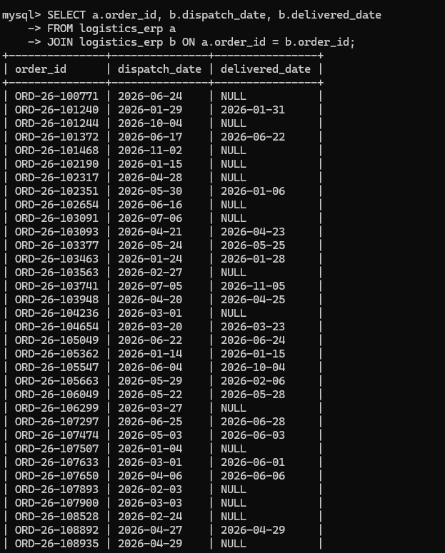

7. SELECT a.customer_id, AVG(b.order_value)

FROM logistics_erp a

JOIN logistics_erp b ON a.customer_id = b.customer_id

GROUP BY a.customer_id;

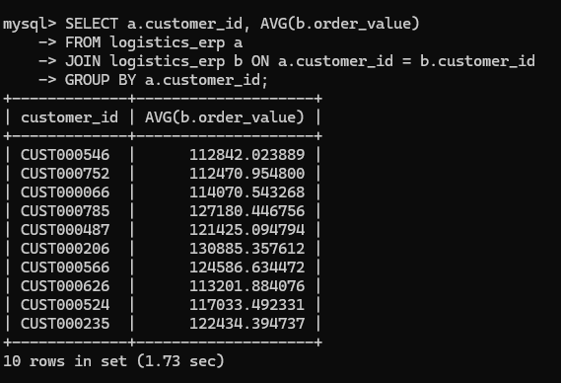

8. SELECT a.product_id, MAX(b.order_qty)

FROM logistics_erp a

JOIN logistics_erp b ON a.product_id = b.product_id

GROUP BY a.product_id;

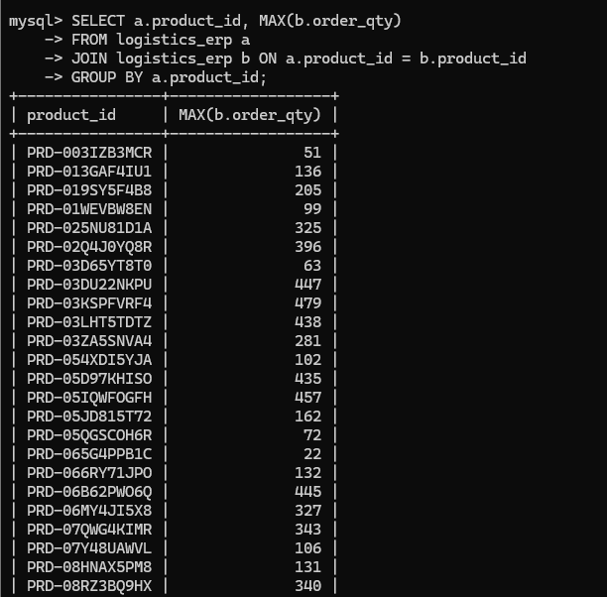

09. SELECT a.customer_id, COUNT(b.order_id)

FROM logistics_erp a

JOIN logistics_erp b ON a.customer_id = b.customer_id

GROUP BY a.customer_id;

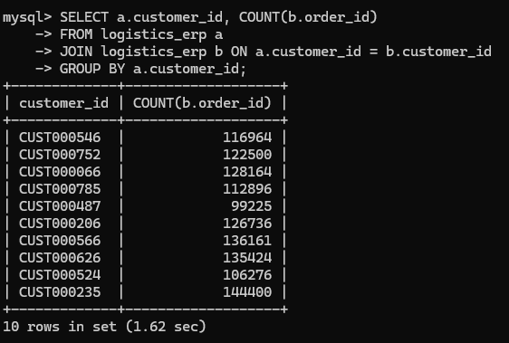

10. SELECT a.product_category, COUNT(DISTINCT b.customer_id) FROM logistics_erp a

JOIN logistics_erp b ON a.product_category = b.product_category

GROUP BY a.product_category;

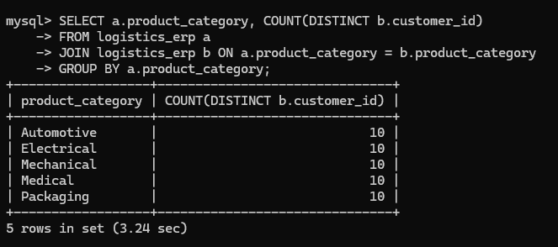

11. SELECT a.order_date, SUM(b.order_value)

FROM logistics_erp a

JOIN logistics_erp b ON a.order_date = b.order_date

GROUP BY a.order_date;

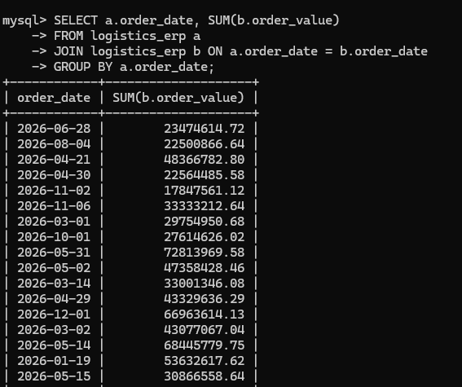

12 . SELECT a.shipment_status, COUNT(b.order_id)

FROM logistics_erp a

JOIN logistics_erp b ON a.shipment_status = b.shipment_status

GROUP BY a.shipment_status;

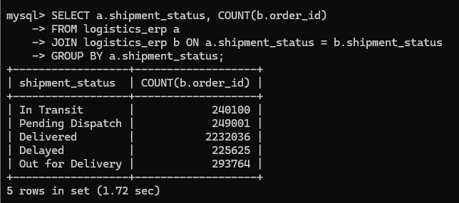

13. SELECT a.product_name, SUM(b.order_qty)

FROM logistics_erp a

JOIN logistics_erp b ON a.product_name = b.product_name

GROUP BY a.product_name;

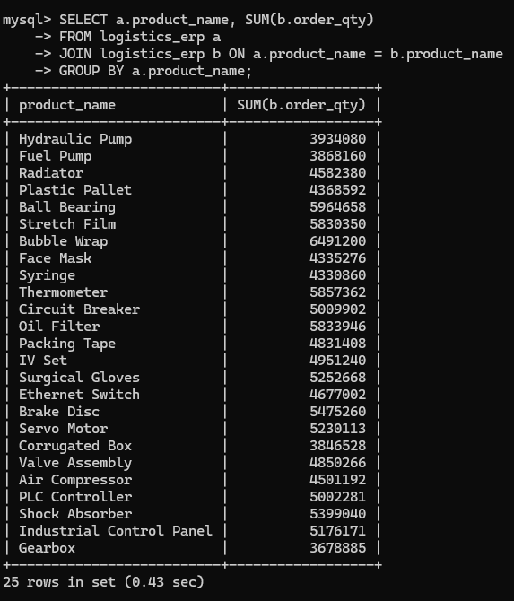

14 SELECT a.customer_id, MIN(b.order_value)

FROM logistics_erp a

JOIN logistics_erp b ON a.customer_id = b.customer_id

GROUP BY a.customer_id;

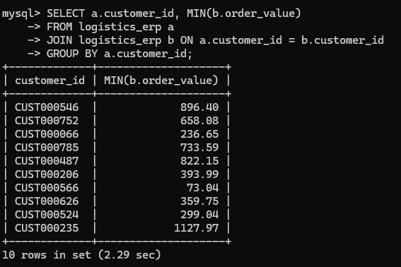

15. SELECT a.product_id, AVG(b.order_qty)

FROM logistics_erp a

JOIN logistics_erp b ON a.product_id = b.product_id

GROUP BY a.product_id;

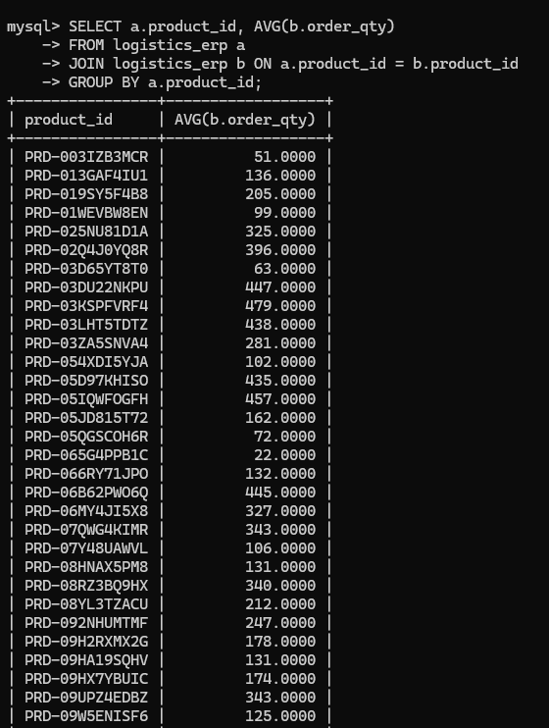

16.SELECT a.courier, AVG(DATEDIFF(b.delivered_date, b.dispatch_date)) FROM logistics_erp a

JOIN logistics_erp b ON a.courier = b.courier

GROUP BY a.courier;

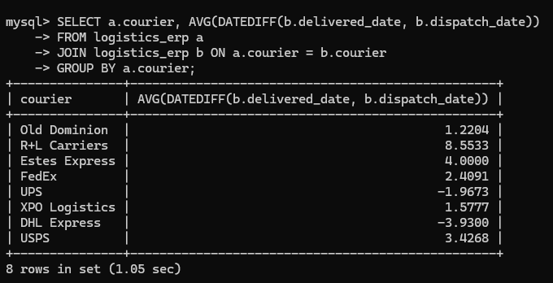

17. SELECT a.customer_id, COUNT(DISTINCT b.order_date)

FROM logistics_erp a JOIN logistics_erp b ON a.customer_id = b.customer_id

GROUP BY a.customer_id;

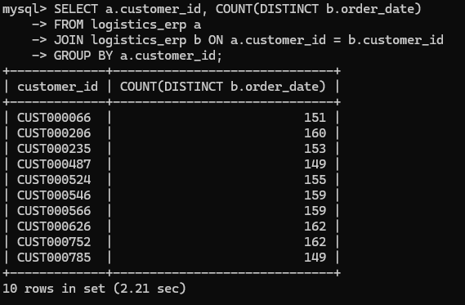

18. SELECT a.product_category, MAX(b.order_value)

FROM logistics_erp a

JOIN logistics_erp b ON a.product_category = b.product_category

GROUP BY a.product_category;

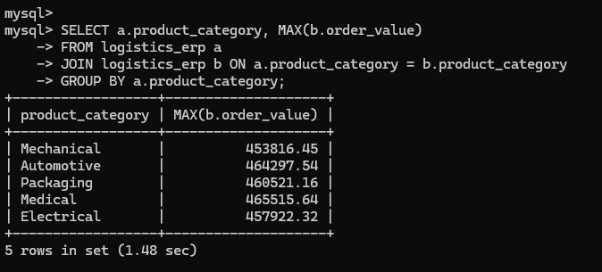

19. SELECT a.warehouse, COUNT(DISTINCT b.product_id)

FROM logistics_erp a

JOIN logistics_erp b ON a.warehouse = b.warehouse

GROUP BY a.warehouse;

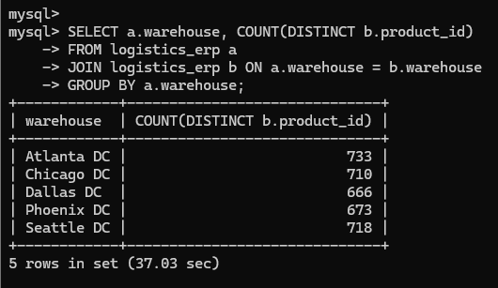

20. SELECT a.customer_id, SUM(b.order_qty)

FROM logistics_erp a

JOIN logistics_erp b ON a.customer_id = b.customer_id

GROUP BY a.customer_id;

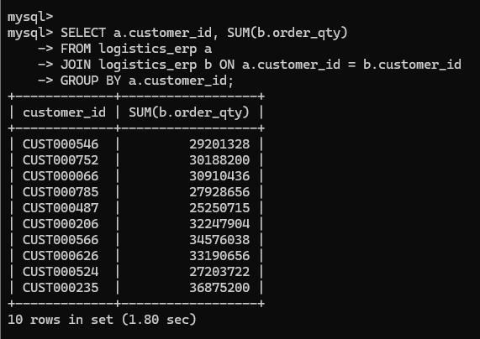

21 SELECT a.product_id, SUM(b.order_value)

FROM logistics_erp a

JOIN logistics_erp b ON a.product_id = b.product_id

GROUP BY a.product_id;

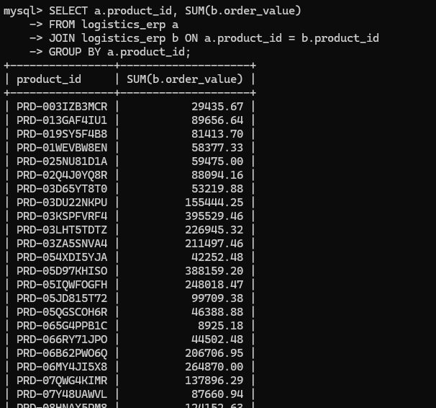

22 SELECT a.order_id, COUNT(b.product_id)

FROM logistics_erp a

JOIN logistics_erp b ON a.order_id = b.order_id

GROUP BY a.order_id;

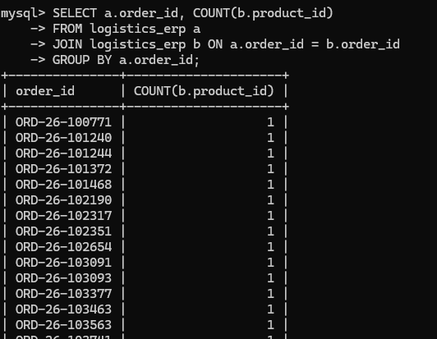

23 SELECT a.product_category, AVG(b.order_value)

FROM logistics_erp a

JOIN logistics_erp b ON a.product_category = b.product_category

GROUP BY a.product_category;

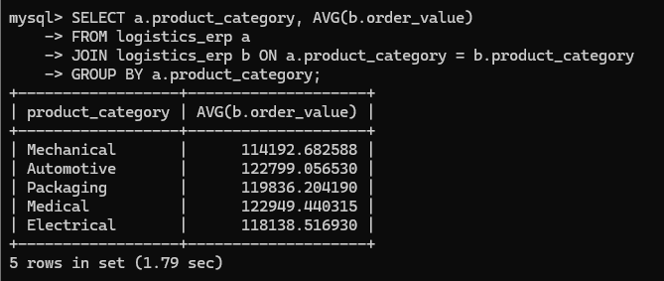

24 SELECT a.customer_id, MAX(b.order_date)

FROM logistics_erp a

JOIN logistics_erp b ON a.customer_id = b.customer_id

GROUP BY a.customer_id;

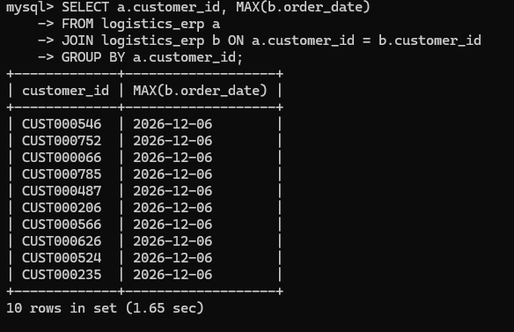

25 SELECT a.courier, SUM(b.order_value)

FROM logistics_erp a

JOIN logistics_erp b ON a.courier = b.courier

GROUP BY a.courier;

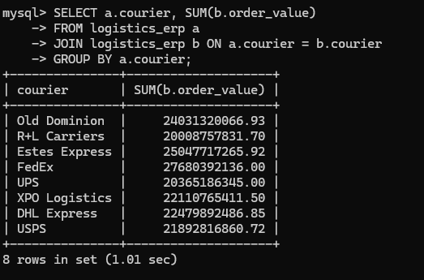

15 Common Table Expressions (CTEs)

WITH cte1 AS ( SELECT customer_id, SUM(order_value) total_sales FROM logistics_erp

GROUP BY customer_id)

SELECT * FROM cte1;

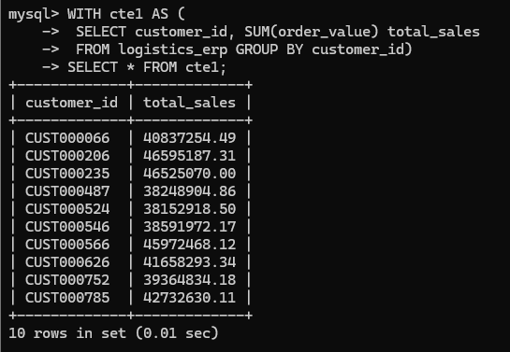

WITH cte2 AS

( SELECT product_id, SUM(order_qty) qty

FROM logistics_erp

GROUP BY product_id)

SELECT * FROM cte2;

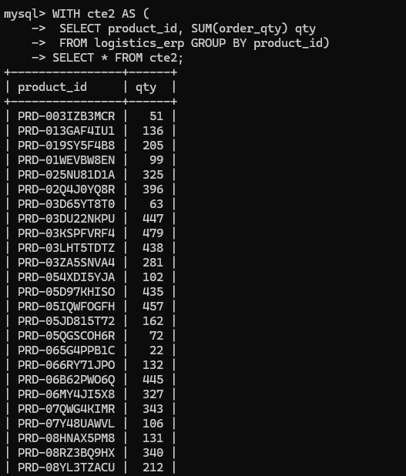

WITH cte3 AS

( SELECT courier, COUNT(*) cnt

FROM logistics_erp

GROUP BY courier)

SELECT * FROM cte3;

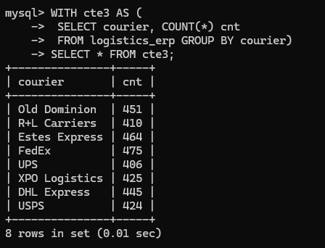

WITH cte4 AS

( SELECT warehouse, SUM(closing_qty) stock

FROM logistics_erp GROUP BY warehouse) SELECT * FROM cte4;
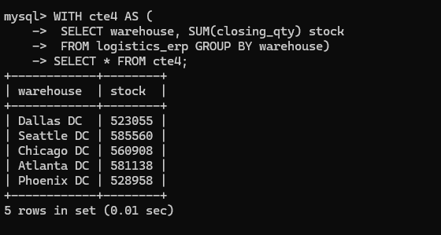

WITH cte5 AS

( SELECT product_category, AVG(order_value) avg_val

FROM logistics_erp

GROUP BY product_category)

SELECT * FROM cte5;
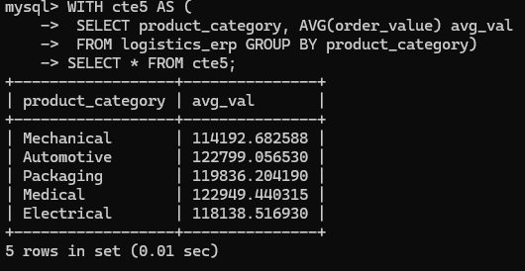

WITH cte6 AS

( SELECT order_id, DATEDIFF(delivered_date, dispatch_date) delay FROM logistics_erp)

SELECT * FROM cte6;
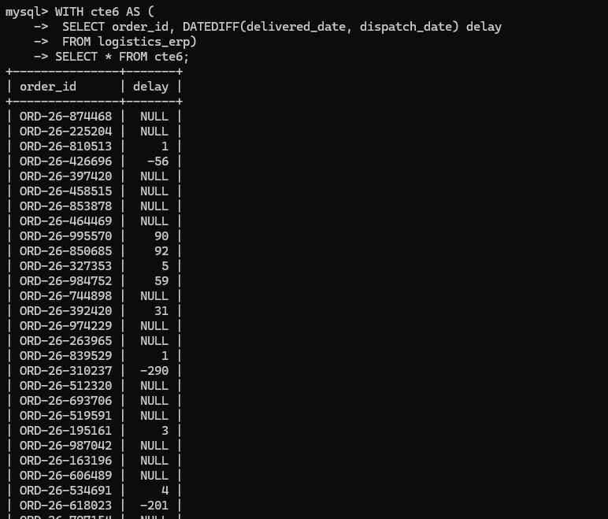

WITH cte7 AS

( SELECT customer_id, COUNT(order_id) cnt

FROM logistics_erp

GROUP BY customer_id)

SELECT * FROM cte7;
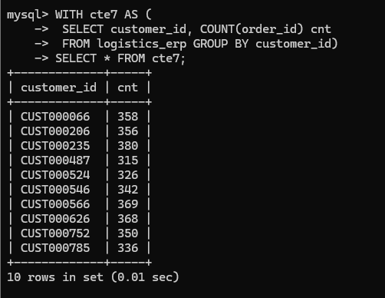

WITH cte8 AS

( SELECT product_name, SUM(order_qty) qty

FROM logistics_erp

GROUP BY product_name)

SELECT * FROM cte8;
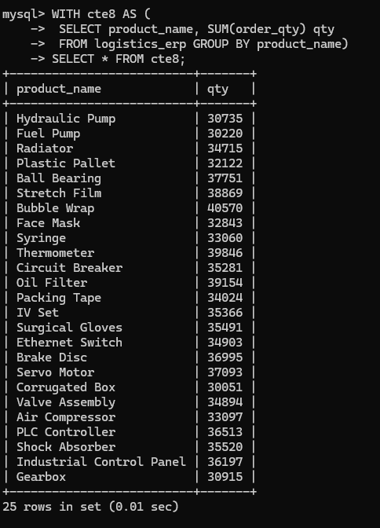

WITH cte9 AS

( SELECT order_date, SUM(order_value) sales

FROM logistics_erp

GROUP BY order_date)

SELECT * FROM cte9;
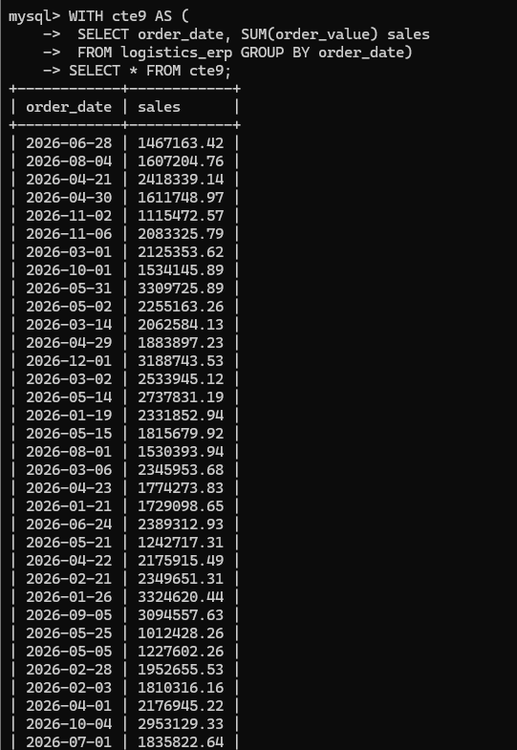

WITH cte10 AS

( SELECT shipment_status, COUNT(*) cnt

FROM logistics_erp

GROUP BY shipment_status)

SELECT * FROM cte10;

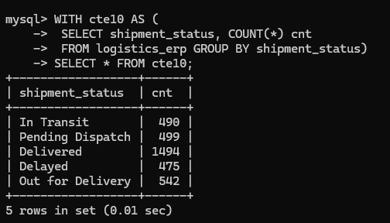

WITH cte11 AS

( SELECT customer_id, MAX(order_value) max_val

FROM logistics_erp

GROUP BY customer_id)

SELECT * FROM cte11;
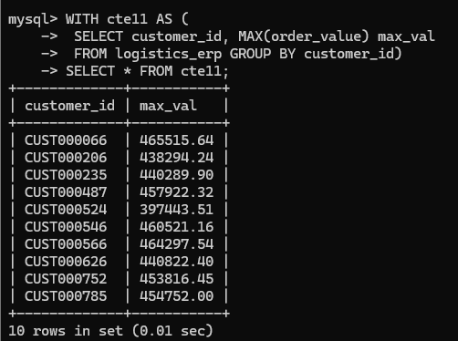

WITH cte12 AS

( SELECT product_id, MIN(order_qty) min_qty

FROM logistics_erp

GROUP BY product_id)

SELECT * FROM cte12;
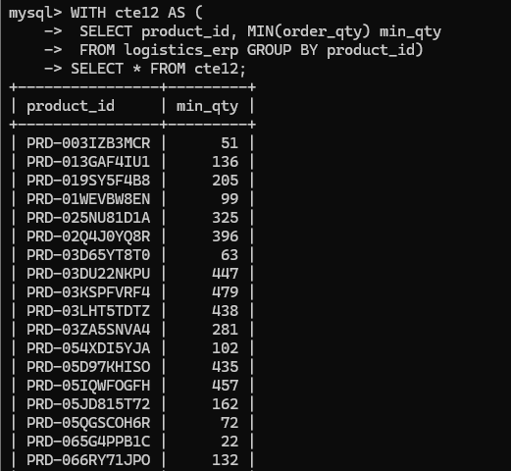

WITH cte13 AS

( SELECT warehouse, AVG(closing_qty) avg_stock

FROM logistics_erp

GROUP BY warehouse)

SELECT * FROM cte13;

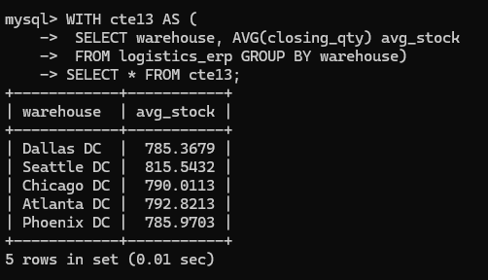

WITH cte14 AS

( SELECT courier, SUM(order_value) total

FROM logistics_erp

GROUP BY courier)

SELECT * FROM cte14;
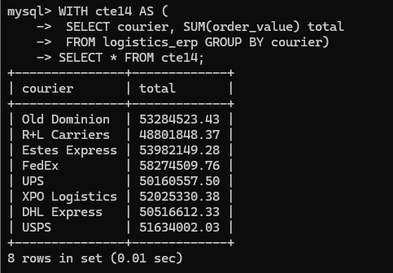

WITH cte15 AS

( SELECT product_category, COUNT(*) cnt

FROM logistics_erp

GROUP BY product_category)

SELECT * FROM cte15;

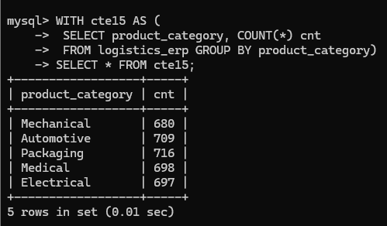

15 Window Function Queries

--1

SELECT order_id, order_value,

RANK() OVER (ORDER BY order_value DESC) rnk

FROM logistics_erp;

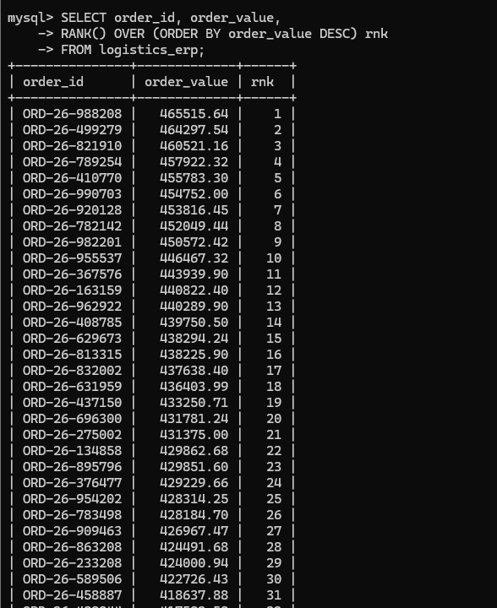

-- 2

SELECT order_id, order_value,

DENSE_RANK() OVER (ORDER BY order_value DESC)

FROM logistics_erp;

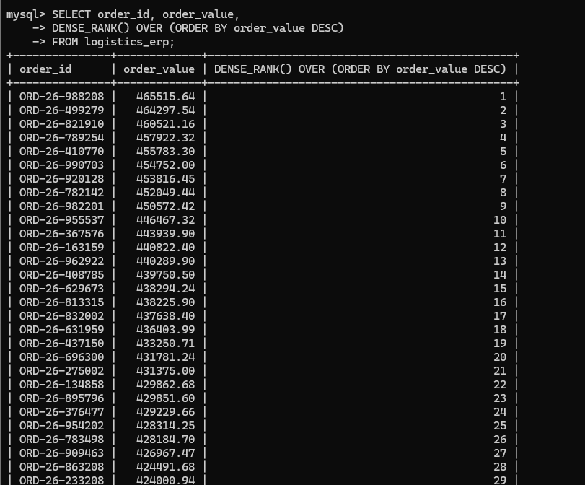

-- 3

SELECT order_id,

ROW_NUMBER() OVER (ORDER BY order_date)

FROM logistics_erp;

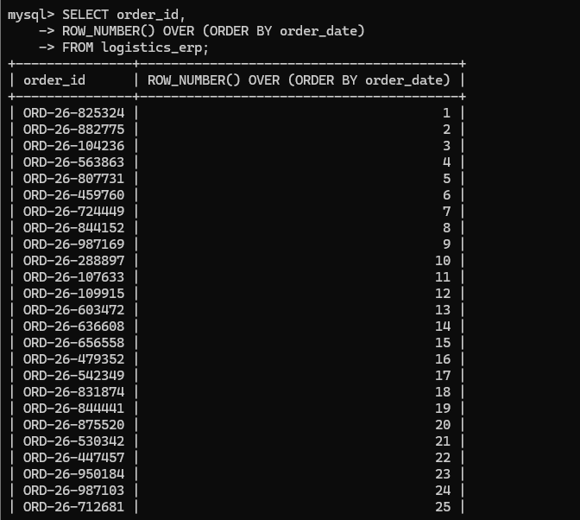

-- 4

SELECT customer_id, order_value,

SUM(order_value) OVER (PARTITION BY customer_id)

FROM logistics_erp;

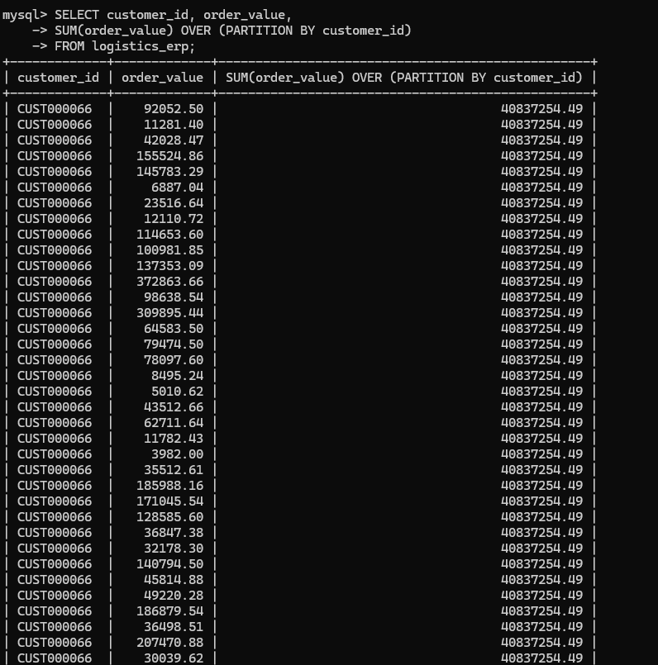

-- 5

SELECT product_id, order_qty,

AVG(order_qty) OVER (PARTITION BY product_id)

FROM logistics_erp;

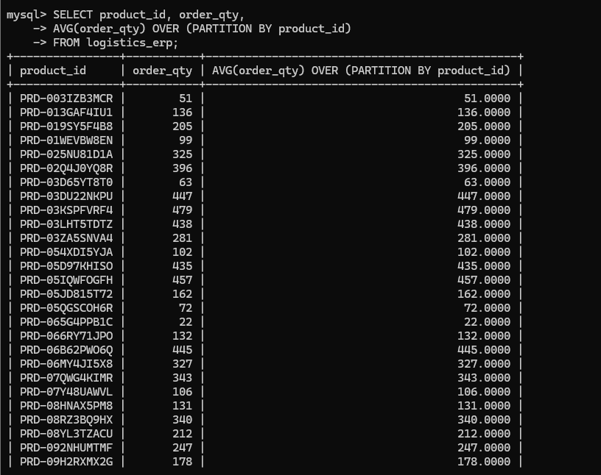

-- 6

SELECT order_id,

LAG(order_value) OVER (ORDER BY order_date)

FROM logistics_erp;

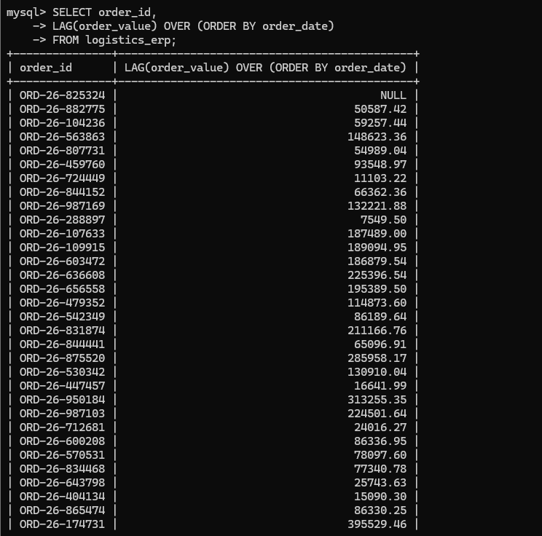

-- 7

SELECT order_id,

LEAD(order_value) OVER (ORDER BY order_date)

FROM logistics_erp;

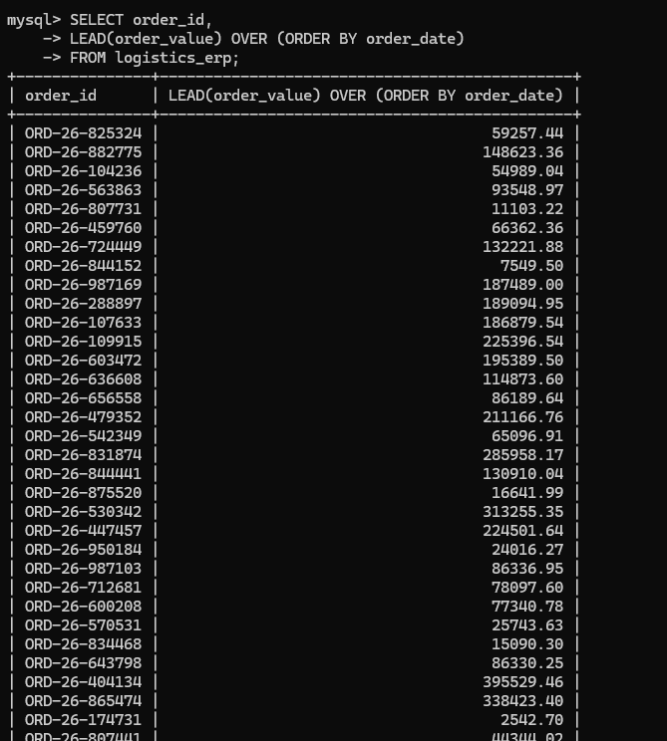

-- 8

SELECT customer_id, order_value,

MAX(order_value) OVER (PARTITION BY customer_id)

FROM logistics_erp;

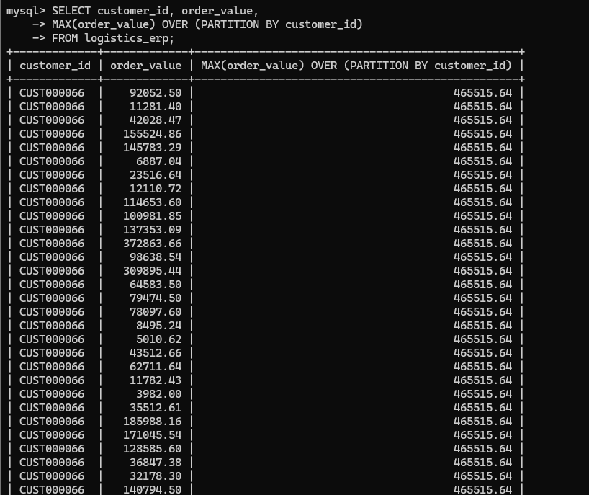

-- 9

SELECT product_id, order_qty,

MIN(order_qty) OVER (PARTITION BY product_id)

FROM logistics_erp;

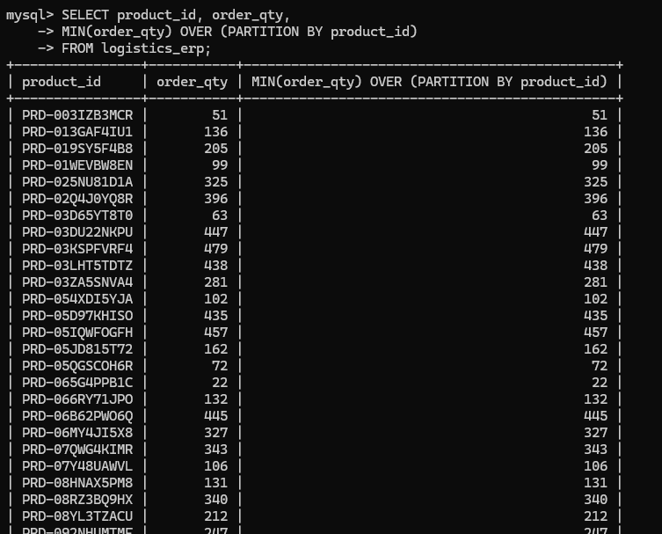

-- 10

SELECT courier,

COUNT(*) OVER (PARTITION BY courier)

FROM logistics_erp;

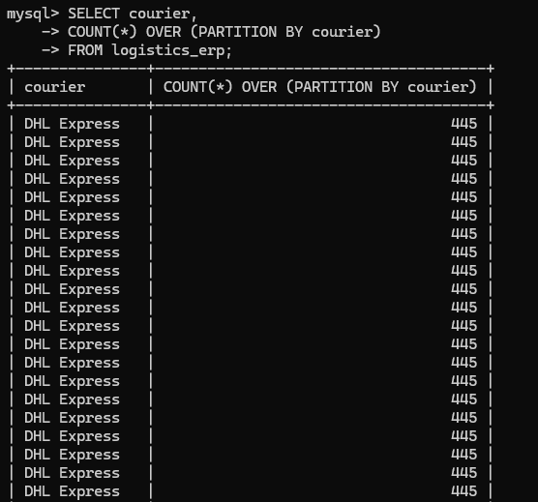

-- 11

SELECT warehouse,

SUM(closing_qty) OVER (PARTITION BY warehouse)

FROM logistics_erp;

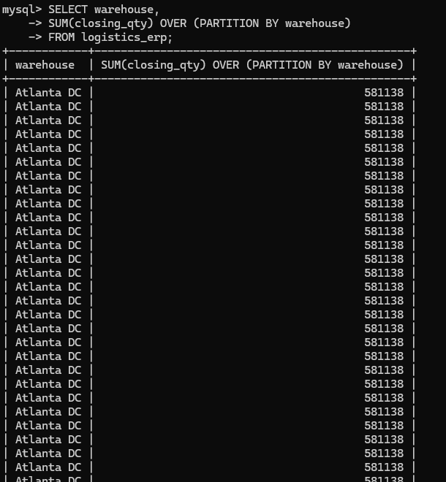

-- 12

SELECT order_date,

SUM(order_value) OVER (ORDER BY order_date)

FROM logistics_erp;

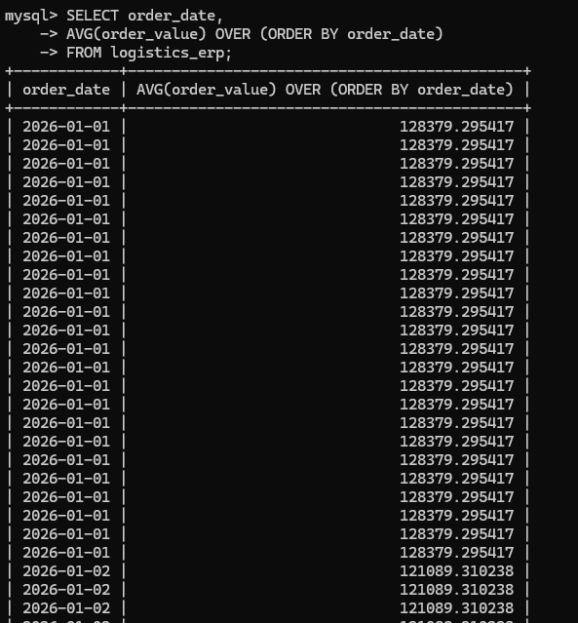

-- 13

SELECT product_category,

RANK() OVER (PARTITION BY product_category ORDER BY order_value DESC)

FROM logistics_erp;

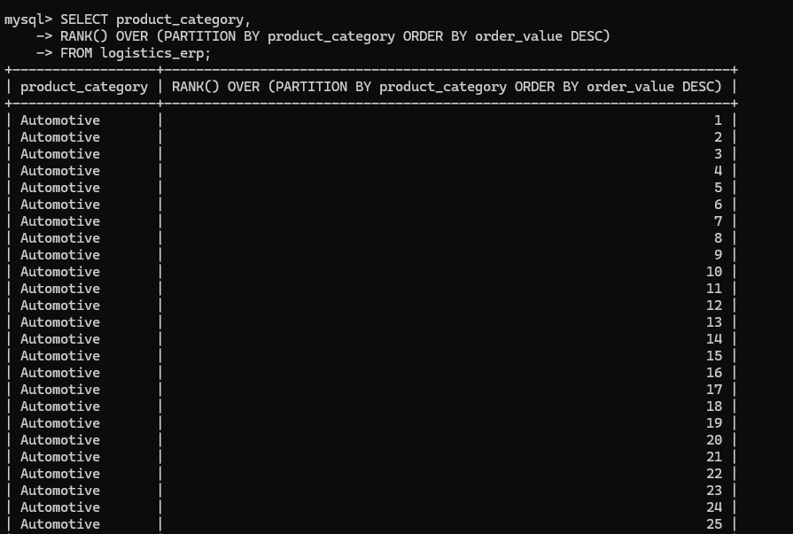

-- 14

SELECT customer_id,

ROW_NUMBER() OVER (PARTITION BY customer_id ORDER BY order_date)

FROM logistics_erp;

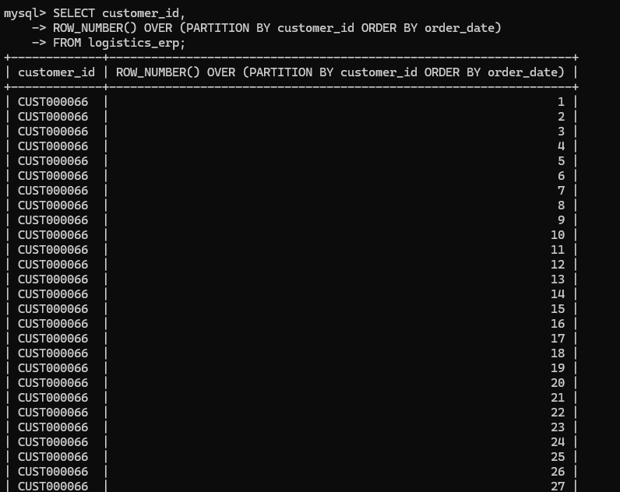

10 Dynamic SQL Queries

-- 1

CREATE PROCEDURE GetCustomerOrders(IN cust_id VARCHAR(20))

BEGIN

SELECT * FROM logistics_erp WHERE customer_id = cust_id;

END$$

-- 2

CREATE PROCEDURE GetOrdersByDate(IN start_date DATE, IN end_date DATE)

BEGIN

SELECT * FROM logistics_erp

WHERE order_date BETWEEN start_date AND end_date;

END$$

-- 3

CREATE PROCEDURE GetTopCustomers()

BEGIN

SELECT customer_id, SUM(order_value) total_sales

FROM logistics_erp

GROUP BY customer_id

ORDER BY total_sales DESC

LIMIT 10;

END$$

-- 4

CREATE PROCEDURE GetProductSales(IN prod_id VARCHAR(20))

BEGIN

SELECT product_id, SUM(order_qty) total_qty

FROM logistics_erp

WHERE product_id = prod_id

GROUP BY product_id;

END$$

-- 5

CREATE PROCEDURE GetCourierPerformance()

BEGIN

SELECT courier,

AVG(DATEDIFF(delivered_date, dispatch_date)) avg_delivery_days

FROM logistics_erp

GROUP BY courier;

END$$

-- 6

CREATE PROCEDURE GetWarehouseStock()

BEGIN

SELECT warehouse, SUM(closing_qty) total_stock

FROM logistics_erp

GROUP BY warehouse;

END$$

-- 7

CREATE PROCEDURE GetDelayedOrders(IN days_limit INT)

BEGIN

SELECT order_id,

DATEDIFF(delivered_date, dispatch_date) delay

FROM logistics_erp

WHERE DATEDIFF(delivered_date, dispatch_date) > days_limit;

END$$

-- 8

CREATE PROCEDURE GetCategorySales()

BEGIN

SELECT product_category, SUM(order_value) total_sales

FROM logistics_erp

GROUP BY product_category;

END$$

-- 9

CREATE PROCEDURE UpdateShipmentStatus(

IN ord_id VARCHAR(20),

IN status_val VARCHAR(50)

)

BEGIN

UPDATE logistics_erp

SET shipment_status = status_val

WHERE order_id = ord_id;

END$$

-- 10

CREATE PROCEDURE GetMonthlySales()

BEGIN

SELECT MONTH(order_date) month,

SUM(order_value) total_sales

FROM logistics_erp

GROUP BY MONTH(order_date);

END$$

DELIMITER ;

10 Stored Procedures

DELIMITER $$

-- 1

CREATE FUNCTION GetDeliveryDays(d DATE, r DATE)

RETURNS INT

DETERMINISTIC

BEGIN

RETURN DATEDIFF(r, d);

END$$

-- 2

CREATE FUNCTION GetDiscount(val DECIMAL(10,2))

RETURNS DECIMAL(10,2)

DETERMINISTIC

BEGIN

RETURN val * 0.9;

END$$

-- 3

CREATE FUNCTION GetTax(val DECIMAL(10,2))

RETURNS DECIMAL(10,2)

DETERMINISTIC

BEGIN

RETURN val * 0.18;

END$$

-- 4

CREATE FUNCTION NetAmount(val DECIMAL(10,2))

RETURNS DECIMAL(10,2)

DETERMINISTIC

BEGIN

RETURN val - (val * 0.1);

END$$

-- 5

CREATE FUNCTION IsDelayed(d DATE, r DATE)

RETURNS VARCHAR(10)

DETERMINISTIC

BEGIN

IF DATEDIFF(r, d) > 5 THEN

RETURN 'YES';

ELSE

RETURN 'NO';

END IF;

END$$

-- 6

CREATE FUNCTION CategoryLabel(cat VARCHAR(50))

RETURNS VARCHAR(50)

DETERMINISTIC

BEGIN

RETURN CONCAT('Category: ', cat);

END$$

-- 7

CREATE FUNCTION DoubleQty(q INT)

RETURNS INT

DETERMINISTIC

BEGIN

RETURN q * 2;

END$$

-- 8

CREATE FUNCTION AvgPrice(val1 DECIMAL(10,2), val2 DECIMAL(10,2))

RETURNS DECIMAL(10,2)

DETERMINISTIC

BEGIN

RETURN (val1 + val2) / 2;

END$$

-- 9

CREATE FUNCTION YearFromDate(d DATE)

RETURNS INT

DETERMINISTIC

BEGIN

RETURN YEAR(d);

END$$

-- 10

CREATE FUNCTION OrderValueCategory(val DECIMAL(10,2))

RETURNS VARCHAR(20)

DETERMINISTIC

BEGIN

IF val > 10000 THEN

RETURN 'HIGH';

ELSEIF val > 5000 THEN

RETURN 'MEDIUM';

ELSE

RETURN 'LOW';

END IF;

END$$

DELIMITER ;

- 10 User Defined Functions

10 User Defined Functions

-- 1

CREATE FUNCTION GetDeliveryDays(d DATE, r DATE)

RETURNS INT

DETERMINISTIC

BEGIN

RETURN DATEDIFF(r, d);

END$$

-- 2

CREATE FUNCTION GetDiscount(val DECIMAL(10,2))

RETURNS DECIMAL(10,2)

DETERMINISTIC

BEGIN

RETURN val * 0.9;

END$$

-- 3

CREATE FUNCTION GetTax(val DECIMAL(10,2))

RETURNS DECIMAL(10,2)

DETERMINISTIC

BEGIN

RETURN val * 0.18;

END$$

-- 4

CREATE FUNCTION NetAmount(val DECIMAL(10,2))

RETURNS DECIMAL(10,2)

DETERMINISTIC

BEGIN

RETURN val - (val * 0.1);

END$$

-- 5

CREATE FUNCTION IsDelayed(d DATE, r DATE)

RETURNS VARCHAR(10)

DETERMINISTIC

BEGIN

IF DATEDIFF(r, d) > 5 THEN

RETURN 'YES';

ELSE

RETURN 'NO';

END IF;

END$$

-- 6

CREATE FUNCTION CategoryLabel(cat VARCHAR(50))

RETURNS VARCHAR(50)

DETERMINISTIC

BEGIN

RETURN CONCAT('Category: ', cat);

END$$

-- 7

CREATE FUNCTION DoubleQty(q INT)

RETURNS INT

DETERMINISTIC

BEGIN

RETURN q * 2;

END$$

-- 8

CREATE FUNCTION AvgPrice(val1 DECIMAL(10,2), val2 DECIMAL(10,2))

RETURNS DECIMAL(10,2)

DETERMINISTIC

BEGIN

RETURN (val1 + val2) / 2;

END$$

-- 9

CREATE FUNCTION YearFromDate(d DATE)

RETURNS INT

DETERMINISTIC

BEGIN

RETURN YEAR(d);

END$$

-- 10

CREATE FUNCTION OrderValueCategory(val DECIMAL(10,2))

RETURNS VARCHAR(20)

DETERMINISTIC

BEGIN

IF val > 10000 THEN

RETURN 'HIGH';

ELSEIF val > 5000 THEN

RETURN 'MEDIUM';

ELSE

RETURN 'LOW';

END IF;

END$$

DELIMITER ;

10 Views

-- 1

CREATE VIEW view_customer_sales AS

SELECT customer_id, SUM(order_value) total_sales

FROM logistics_erp

GROUP BY customer_id;

-- 2

CREATE VIEW view_product_sales AS

SELECT product_id, SUM(order_qty) total_qty

FROM logistics_erp

GROUP BY product_id;

-- 3

CREATE VIEW view_courier_performance AS

SELECT courier,

AVG(DATEDIFF(delivered_date, dispatch_date)) avg_delivery

FROM logistics_erp

GROUP BY courier;

-- 4

CREATE VIEW view_category_sales AS

SELECT product_category, SUM(order_value) total_sales

FROM logistics_erp

GROUP BY product_category;

-- 5

CREATE VIEW view_warehouse_stock AS

SELECT warehouse, SUM(closing_qty) total_stock

FROM logistics_erp

GROUP BY warehouse;

-- 6

CREATE VIEW view_delayed_orders AS

SELECT order_id,

DATEDIFF(delivered_date, dispatch_date) delay

FROM logistics_erp

WHERE DATEDIFF(delivered_date, dispatch_date) > 5;

-- 7

CREATE VIEW view_monthly_sales AS

SELECT MONTH(order_date) month,

SUM(order_value) total_sales

FROM logistics_erp

GROUP BY MONTH(order_date);

-- 8

CREATE VIEW view_top_orders AS

SELECT order_id, order_value

FROM logistics_erp

ORDER BY order_value DESC;

-- 9

CREATE VIEW view_customer_orders_count AS

SELECT customer_id, COUNT(order_id) total_orders

FROM logistics_erp

GROUP BY customer_id;

-- 10

CREATE VIEW view_product_avg_price AS

SELECT product_id, AVG(order_value) avg_price

FROM logistics_erp

GROUP BY product_id;

5 Materialized Views

-- 1

CREATE TABLE mv_customer_sales AS

SELECT customer_id, SUM(order_value) total_sales

FROM logistics_erp GROUP BY customer_id;

-- 2

CREATE TABLE mv_product_sales AS

SELECT product_id, SUM(order_qty) total_qty

FROM logistics_erp GROUP BY product_id;

-- 3

CREATE TABLE mv_courier_stats AS

SELECT courier, COUNT(*) total_orders

FROM logistics_erp GROUP BY courier;

-- 4

CREATE TABLE mv_warehouse_stock AS

SELECT warehouse, SUM(closing_qty) total_stock

FROM logistics_erp GROUP BY warehouse;

-- 5

CREATE TABLE mv_daily_sales AS

SELECT order_date, SUM(order_value) sales

FROM logistics_erp GROUP BY order_date;

5 MERGE Statements

-- 1

INSERT INTO summary_table (customer_id, total_sales)

SELECT customer_id, SUM(order_value)

FROM logistics_erp GROUP BY customer_id

ON DUPLICATE KEY UPDATE total_sales = VALUES(total_sales);

-- 2

INSERT INTO product_summary (product_id, total_qty)

SELECT product_id, SUM(order_qty)

FROM logistics_erp GROUP BY product_id

ON DUPLICATE KEY UPDATE total_qty = VALUES(total_qty);

-- 3

INSERT INTO courier_summary (courier, total_orders)

SELECT courier, COUNT(*)

FROM logistics_erp GROUP BY courier

ON DUPLICATE KEY UPDATE total_orders = VALUES(total_orders);

-- 4

INSERT INTO warehouse_summary (warehouse, total_stock)

SELECT warehouse, SUM(closing_qty)

FROM logistics_erp GROUP BY warehouse

ON DUPLICATE KEY UPDATE total_stock = VALUES(total_stock);

-- 5

INSERT INTO daily_summary (order_date, sales)

SELECT order_date, SUM(order_value)

FROM logistics_erp GROUP BY order_date

ON DUPLICATE KEY UPDATE sales = VALUES(sales);

5 Recursive CTEs

-- 1
WITH RECURSIVE seq AS (
SELECT 1 n
UNION ALL
SELECT n+1 FROM seq WHERE n < 10
)
SELECT * FROM seq;

-- 2
WITH RECURSIVE dates AS (
SELECT MIN(order_date) d FROM logistics_erp
UNION ALL
SELECT DATE_ADD(d, INTERVAL 1 DAY)
FROM dates WHERE d < (SELECT MAX(order_date) FROM logistics_erp)
)
SELECT * FROM dates;

-- 3
WITH RECURSIVE nums AS (
SELECT 1 n
UNION ALL
SELECT n+2 FROM nums WHERE n < 20
)
SELECT * FROM nums;

-- 4
WITH RECURSIVE factorial AS (
SELECT 1 n, 1 fact
UNION ALL
SELECT n+1, fact*(n+1) FROM factorial WHERE n < 5
)
SELECT * FROM factorial;

-- 5
WITH RECURSIVE hierarchy AS (
SELECT customer_id, 1 lvl FROM logistics_erp
UNION ALL
SELECT customer_id, lvl+1 FROM hierarchy WHERE lvl < 3
)
SELECT * FROM hierarchy;

